**Assignment -1**

HTML & Python programming

|  |  |
| --- | --- |
| Assignment Date | 25 September 2022 |
| Student Name | Shabeen Soniya.A |
| Student Roll Number | 962219106063 |
| Maximum Marks | 2 Marks |

**Question-1:**

Create User table with user with email, username, roll number, password.

**Solutions:**

<td></td>

</tr>

<tr>

<th>User 4</th>

<td></td>

<td></td>

<td></td>

<td></td>

</table><table border="1">

<tr>

<th></th>

<th>User name</th>

<th>User email</th>

<th>Roll number</th>

<th>Password</th>

</tr>

<tr>

<th>User 1</th>

<td></td>

<td></td>

<td></td>

<td></td>

</tr>

<tr>

<th>User 2</th>

<td></td>

<td></td>

<td></td>

<td></td>

</tr>

<tr>

<th>User 3</th>

<td></td>

<td></td>

<td></td>

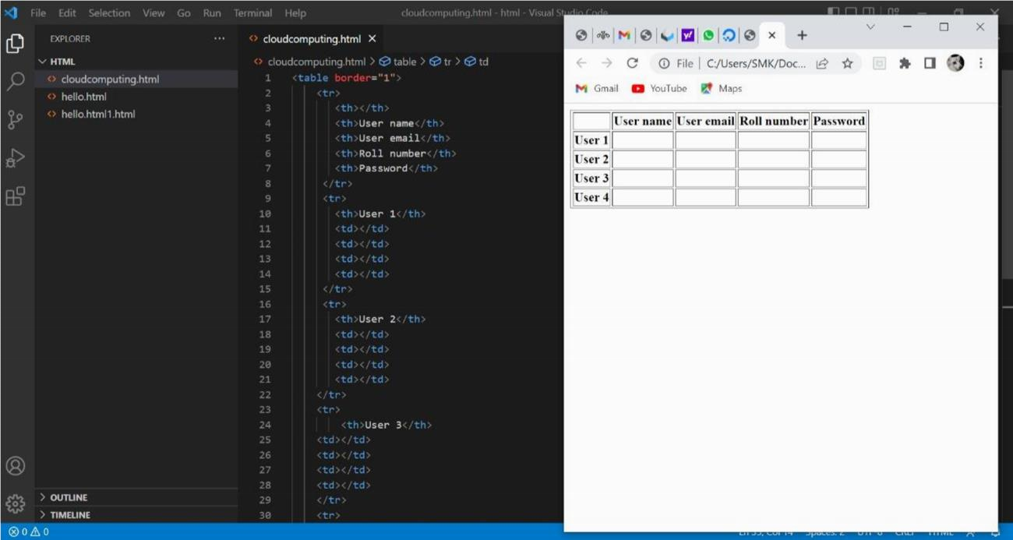

Perform UPDATE, DELETE Queries with user table.

**Solution:**

<div>

<h1>Update Data and Delete Data In HTML</h1>

<input type="hidden" id="id" />

<b>User name:</b><input type="text" id="firstName" /><br />

<b>User Email:</b><input type="text" id="lastName" /><br />

<b>Roll Number:</b><input type="text" id="city" /><br />

<b>Password:</b><input type="text" id="state" /><br />

<button onclick="UpdateData()">Update Data</button>

<button onclick="ClearData()">Clear</button>

<br />

<br />

<br />

<div id="details"></div>

</div>

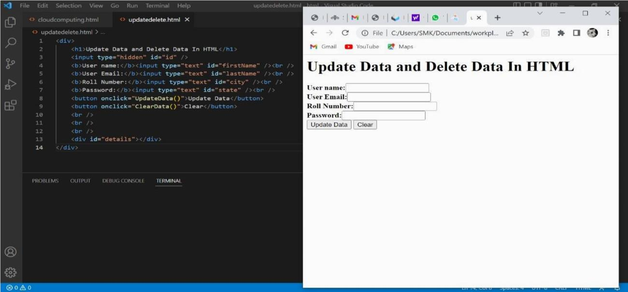

Connect python code to db2. **Solution:** dsn_driver = connection_data['dsn_driver'] dsn_database = connection_data['dsn_database'] dsn_hostname = connection_data['dsn_hostname'] dsn_port = connection_data['dsn_port'] dsn_protocol = connection_data['dsn_protocol'] dsn_uid = connection_data['dsn_uid'] dsn_pwd = connection_data['dsn_pwd']

dsn = (

"DRIVER={0};"

"DATABASE={1};"

"HOSTNAME={2};"

"PORT={3};"

"PROTOCOL={4};"

"UID={5};"

"PWD={6};").format(dsn_driver, dsn_database, dsn_hostname, dsn_port, dsn_protocol, dsn_uid, dsn_pwd) try:

connection = ibm_db.connect(dsn, "", "") print("Connected to database: ", dsn_database, "as user: ", dsn_uid, "on host: ", dsn_hostname) return connection

except: print("Unable to connect: ", ibm_db.

Create a flask app with registration page, login page and welcome page. By default load the registration page once the user enters all the fields store the data in database and navigate to login page authenticate user username and password. If theuser is valid show the welcome page.

**Solution:**

<!-- Store this code in 'login.html' file inside the 'templates' folder -->

<html>

<head>

<meta charset="UTF-8">

<title> Login </title>

<link rel="stylesheet" href="{{ url_for('static', filename='style.css') }}">

</head>

<body></br></br></br></br></br>

<div align="center">

<div align="center" class="border">

<div class="header">

<h1 class="word">Login</h1>

</div></br></br></br>

<h2 class="word">

<form action="{{ url_for('login') }}" method="post">

<div class="msg">{{ msg }}</div>

<input id="username" name="username" type="text" placeholder="Enter Your Username" class="textbox"/></br></br>

<input id="password" name="password" type="password" placeholder="Enter Your Password" class="textbox"/></br></br></br>

<input type="submit" class="btn" value="Sign In"></br></br>

</form>

</h2>

<p class="bottom">Don't have an account? <a class="bottom" href="{{url_for('register')}}"> Sign Up here</a></p>

</div>

</div>

<

/body>



<



/html



>

